Points: _______ /48  0-15= start studying! 16-32= you can do better 33- 48= well done | Preverjanje |  | Touchstone 9, Units 2, 3  Name: ………………………..…………………….

I. Active or passive voice (Past)? Tvornik ali trpnik – postavi glagole v oklepaju v ustrezno obliko. __/9
Ronald Reagan was (be) the president of the U.S. from 1981 to 1989. Before he was elected (elect), he was the governor of California. Even before that, he worked (work) in Hollywood as an actor. In 1981, something terrible happened (happen). Reagan's car was stopped (stop) by someone, and as he was getting out, he was shot (shoot) by an assassin. He didn't die from the gunshot wounds and he soon recovered (recover). One of his assistants was wounded (wound) more seriously. Because of the attack many of the laws on weapons were changed (change).

II. Change the sentences from active to passive voice or vice versa. Use the same tense and form. Spremeni povedi iz tvornega v trpni način ali obratno. Uporabi enak čas in obliko povedi. __/4
1. Lucy is loved by everyone.
Everyone loves Lucy.
2. Was the police officer called to the scene of the accident by the victims?
Did the victims call the police officer to the scene of the accident?
3. They don't make many films in Slovenia.
Many films aren't made in Slovenia. / Not many films are made in Slovenia.
4. Is the best sportsman chosen by a committee?
Does a committee choose the best sportsman?

III. Rewrite the sentences without changing the meaning. Use If-clauses (types 0, 1 or 2). Preoblikuj povedi, ne da jim spremeniš pomen. Uporabi pogojnike (tip 0, 1 ali 2). __/4

1. You mix yellow and blue, and you get green.
If you mix yellow and blue, you get green. (Type 0)
2. I don't have enough money so I can't buy this dress.
If I had enough money, I would buy this dress. (Type 2)
3. You will go to a party and you will meet some new friends.
If you go to a party, you will meet some new friends. (Type 1)
4. Jack won't stop eating so much. He will be sick.
Jack will be sick unless he stops eating so much. (Type 1)

IV. Make an If-chain. Tvori verigo if stavkov. Napiši vsaj 4 povedi. __/4
Če bi bil/a fant/punca, ….

If I were a boy/girl, I would ….( 2 primera)

If I were a girl, I would fight crime. If I fought crime, I would get shot. If I got shot, I would die. If I died, people would be sad. If people were sad, I would raise from the dead. If I raised from the dead, I would catch all the criminals.
If I were a girl, I would do girl’s stuff. If I did girl’s stuff, people would think I was a girl. If people thought I was a girl, I would become a boy again. If I became a boy again, everything would be normal.

V. Translate the sentences. Prevedi spodnje povedi. __/5
1. Na tvojem mestu bi povedala resnico. If I were you, I would tell the truth.
2. Prepovedano kaditi. No smoking. / Smoking forbidden. / Not allowed to smoke./Prohibited.
3. Večino igrač izdelajo na Kitajskem. Most toys are made in China.
4. Veselim se najinega srečanja. I'm looking forward to seeing you.
5. Ko bom prišel domov, te pokličem. I'll call you when I get home.

VI. Fill in the verbs in the correct form. Postavi glagole v oklepaju v ustrezno obliko in čas. Glej primer ø, ki je že rešen. __/8

Mum: Daisy! Where (ø) are (be) you?

Dad: She’s upstairs, in the bathroom! She (1) is taking (take) a shower.
Mum: Again! She (2) has already been (already be) in the bathroom today. She won’t get to school in time unless she (3) hurries (hurry) up. Daisy! Come downstairs immediately!
Dad: Oh, (4)stop shouting (shout), love. She (5) will come (come) downstairs when she (6) is (be) ready.

Mum: Oh, George, I really don’t get it! You always take her side. It’s not fair!
Dad: That’s not true and you know it. After all, our daughter is a teenager. No wonder she spends hours in the bathroom. What (7) will her friends say (her friends say) if she turns up at school without wearing her make-up.

Mum: When I (8) was (be) her age I ...

Dad: Calm down. Let’s have a cup of tea.

VII. What's in the picture? Kaj je na sliki? __/4

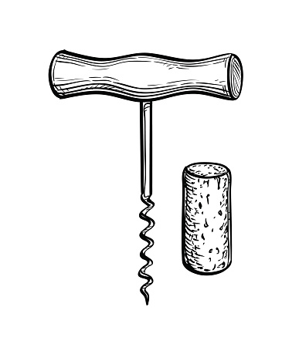 | 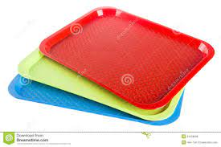 | 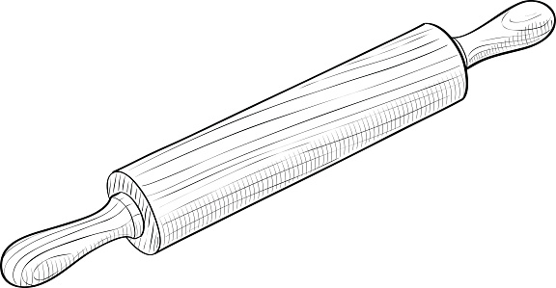 | 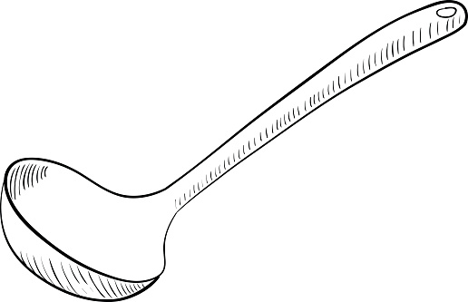
CORKSCREW | TRAY | ROLLING PIN | LADLE

VIII. Match Slovenian dishes with descriptions in English. Poveži jedi z njihovimi opisi. __/2
1. kuhana šunka s hrenom | _4__ maize porridge topped by cracklings
2. orehova potica | _3_ black pudding with sauerkraut
3. krvavice s kislim zeljem | _1__ boiled ham with horseradish
4. koruzni žganci z ocvirki | _2__ walnut roll
IX. Translate into English. Prevedi v angleščino. __/8
sesekljati na kocke | chop | glavna jed | main course
narezati na rezine (kruh) | slice | svinjski kotlet | pork chop
cvetača | cauliflower | goveja juha z rezanci | beef soup with noodles
perutnina | poultry | kuhati na pari | steam

VIII. At the restaurant. Complete the conversation. Dopolni pogovor v restavraciji. (8P)

Waiter: Hello. Welcome to Joe's Grill. Here is your MENU Let me know when you're ready.

…

Guest: Waiter - I am ready TO ORDER.

Waiter: Certainly. What can I get you?

Guest: I WOULD / 'D like the soup of the day and some mineral water.

Waiter: And for your main COURSE?

Guest: Grilled chicken and a jacket potato.

….

Waiter: Here YOU ARE. Would you like a dessert?

Guest: Yes, I'd like some APPLE PIE/ICE CREAM/PANCAKES…

…

Guest: Waiter, can I get the BILL please?

Waiter: Certainly. Thank you for EATING/COMING here.

Prevedi v TJA:
- mixed
- Gradbeniki popravljajo stavbe in mostove.
- Kite lovijo zaradi masti, slone pa zaradi oklov.
- Če ne boš pohitel, ne bomo prišli pravočasno.
- Takoj ko boš prišel v šolo, bomo pisali zgodovino.
- Če bi bil starejši, bi lahko delal izpit za avto.
- Nima smisla razlagati še enkrat. Zakaj nisi poslušal/a?
- Ta jogurt je bil narejen v Nemčiji, pripeljan v SLO in prodan v trgovini.
- Obtožili so ga ponarejanja denarja.
- Ljudi so posvarili pred nevarnostjo plazu.
- Sestanek je bil odpovedan.
- Ljudje so pili veliko alkohola na zabavi.
- Svetovano nam je jesti veliko sadja in zelenjave.
- Njegov avto je bil ukraden in zažgan.
- Vozili smo hitro, a smo bili prehitevani od veliko avtomobilov.
- Ta cesta ni veliko v uporabi.
- Vsi poleti so bili odpovedani zaradi megle.
- Nekdo počisti to sobo vsak dan.
- Za kaj se uporablja srebro?

