PREVERJANJE PRED DRUGIM TESTOM _______/65 Name: _________________________

1. Tense forms. Postavi povedi v različne oblike. _____/10
TRDILNA | NIKALNA | VPRAŠALNA
Mary reads comics. | MARY DOESN'T READ COMICS. | DOES MARY READ COMICS?
WE DROVE FAST. | We didn't drive fast. | DID WE DRIVE FAST?
THE PHONE WAS RINGING. | THE PHONE WASN'T RINGING. | Was the phone ringing?
He's sleeping. | HE ISN'T SLEEPING. | IS HE SLEEPING?
THEY WERE TIRED. | They weren't tired. | WERE THEY TIRED?

2. Present Simple ali Present Continuous. ______/8

Max IS (be) a boy from Exeter. He GOES (go) to Westover School. At the moment
he IS SITTING (sit) in the classroom, but he ISN'T LISTENING (not listen) to the teacher - he
IS THINKING (think) about the weekend. On Fridays school usually FINISHES (finish) at 3 pm. Max always GETS (get) a ride home with his mum. He IS WAITING (wait) for her right now. The weekend is finally here!

3. Past Simple. Dopolni povedi - uporabi glagole v navadnem pretekliku. ____/10
1. Where WAS (be) Scott at the weekend?
2. We BOUGHT (buy) a new computer game last weekend.
3. He STOPPED (stop) in front of the house. DID you SEE (see) him?
4. I WOKE (wake) up early yesterday.
5. What DID you ASK (ask) your friend?
6. She DIDN'T EAT (not eat) the cake, but she ATE (eat) the muffins.
7. They WEREN'T (not be) home yesterday. They WENT (go) to the cinema.

4. Past Continuous. Postavi glagole v Past Continuous. ____/4
1. I WAS HAVING (have) a shower when my mum called.
2. While my brother WAS STUDYING (study), my grandma made some muffins.
3. We WERE LYING (lie) in bed when the phone rang.
4. WAS she RUNNING (run) when you saw her?

5. Past Simple or Past Continuous. Kratko ali dolgo dejanje? Podčrtaj pravilno obliko. ____/6
Jack rode/was riding his bike when he fell/was falling.
I didn't sleep/wasn't sleeping when you called/were calling.
My sister read/was reading while my dad watched/was watching.
6. Translate. Prevedi v angleščino. _____/12

pločnik | PAVEMENT, SIDEWALK | semafor | TRAFFIC LIGHTS
cerkev | CHURCH | knjigarna | BOOKSHOP
trafika | NEWSAGENT'S | trg | SQUARE
nebotičnik | SKYSCRAPER | zdravstveni dom | HEALTH CENTRE
mesar | BUTCHER | natakarica | WAITRESS
vodovodar | PLUMBER | sodnik | JUDGE

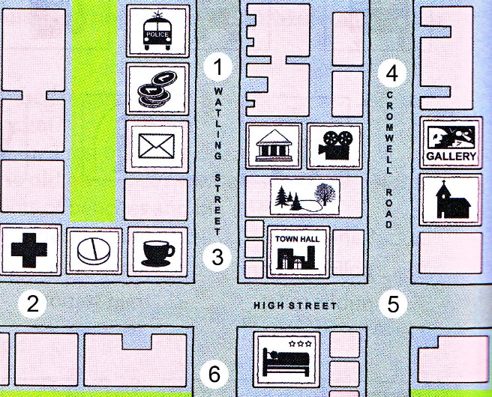
7. Oglej si zemljevid in dopolni besedilo. ____/5
- A: Do you know if there is a bank near here?
B: Yes, it’s BETWEEN the post office and the police station.
- A: Excuse me, can you tell me where the Regency Hotel is?
B: It’s in High Street, OPPOSITE the Town Hall.
- A: Let’s meet at Lenny’s café.
B: Is that the one ON/IN THE CORNER OF High Street and Watling Street?
- A: Where are we meeting John and Linda?
B: We agreed to meet IN FRONT OF/BY the cinema on Cromwell Road.
- A: Where can I get some aspirin? I’ve got a terrible headache.
B: There’s a chemist's NEXT TO/BESIDE/BY/NEAR the hospital.

8. Dopolni besedilo z besedami iz okvirčka. Tri besede so odveč. ____/6
through past straight excuse next to opposite along crossroads roundabout
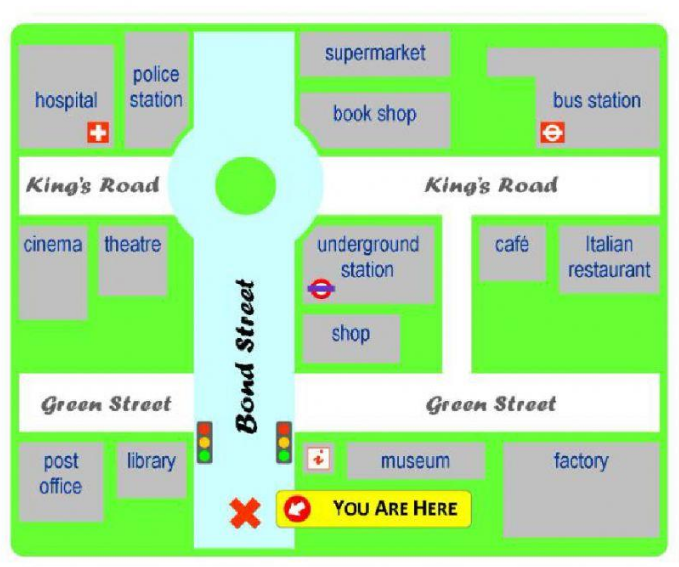
Excuse me, can you tell me the way to the bus station. Sure. Go ALONG Bond Street. Go PAST the shop and the underground station. At the ROUNDABOUT turn right. Go STRAIGHT on until you see the bus stations on your left. It's OPPOSITE the Italian restaurant.

9. WH-questions. Tvori WH-vprašanja – vprašaj po podčrtanem izrazu. ____/4
I wear my baseball cap every day. WHAT DO I/YOU WEAR EVERY DAY?
She washed her hair on Saturday. WHEN DID SHE WASH HER HAIR?
He is sleeping on the sofa. WHERE IS HE SLEEPING?
She was calling her friend. WHO WAS SHE CALLING?

