**1. Opiši sliko. Napiši čim več stavkov.**

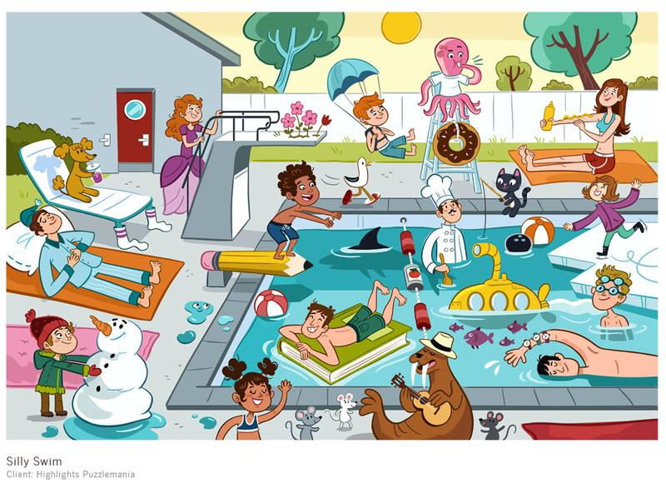

|  |
| --- |
|  |
|  |
|  |
|  |
|  |
|  |
|  |
|  |

**2. Present Simple. Postavi glagole v navadni sedanjik. Možna je tudi nikalna oblika!**

I can’t wait for summer holidays to begin! Summer is my favourite time of the year, because I ________________ (like) winters. I usually ___________________ (spend) a few weeks of summer with my grandparents. I ___________________ (play) outside most of the time, because they ___________________ (have) a TV. Grandpa _____________________ (take) me fishing or mountain climbing. Grandma ____________________ (bake) wonderful desserts and she _________________ (be) a great cook! She ______________________ (cook) any meat, because she is a vegetarian. But I don’t mind, I _________________ (love) her cooking.

**3. Dopolni besedilo.**

Before I go shopping I always write a shopping ______________. I usually check what food I’ve got __________ my fridge. Let’s see. There’s still __________ milk, cheese and butter. But I haven’t got _________ eggs. I want to bake a ___________ for John. It’s _________ birthday tomorrow! Have I __________ any sugar? Yes. What about something to drink? Some water and ________ carton of juice. I better go now. Mum ___________ waiting for me outside. I _______ coming! Mum, ____________ you have your wallet?

**4. Na vprašanja na kratko odgovori.**

|  |  |  |  |
| --- | --- | --- | --- |
| Does Joe like sports? | Yes, ________________ | Is there a castle in Bled? | Yes, ________________ |
| Are you OK? | No, ________________ | Are there any hospitals? | No, ________________ |
| Can Sadie swim? | Yes, ________________ | Has Lisa got a sister? | Yes, ________________ |
| Are your parents nice? | Yes, ________________ | Are we swimming? | No, ________________ |
| Do dogs bark? | Yes, ________________ | Does he have a car? | Yes, ________________ |
| Is the dog barking? | No, ________________ | Am I having fun? | Yes, ________________ |

**5. Postavi WH-vprašanja.**

|  |  |
| --- | --- |
| 1. She lives **in a big house.** |  |
| 2. Our teachers go to work **by car.** |  |
| 3. Sadie's got **two** cousins. |  |
| 4. My sister listens to **rock** music. |  |
| 5. He can swim **for 2 hours**. |  |
| 6. My mum is cooking **lunch.** |  |
| 7. This is **Mike's** bike. |  |
| 8. Sadie doesn't eat **meat.** |  |

**6. Reši križanko.**

**Across**

4. omara

6. umivalnik

10. med (dvema hišama)

13. nasproti

14. hladilnik

16. kuhinjske omarice

17. krožniki

19. naslanjač

20. živa meja

**Down**

1. zelenica

2. hiša dvojček

3. stopnice

5. pralni stroj

7. žlice

8. police

9. predalnik

11. ribnik

12. pomivalni stroj

15. klet

17. shramba

18. banja