besedišče

1. naloga

**Poišči besede za stvari, ki so označene na sliki. Črke izbranih besed vpiši v razpredelnico. Dve besedi sta odveč. Glej primer 0, ki je že rešen.**

|  |  |  |  |  |  |  |  |  |
| --- | --- | --- | --- | --- | --- | --- | --- | --- |
| **A** bottle |  | **B** clock |  | **C** cup |  | **D** glass |  | **E** letter |
|  |  |  |  |  |  |  |  |  |
| **F** newspaper |  | **G** ruler |  | **H** waiter |  | **I** watch |  | **J** window |
|  |  |  |  |  |  |  |  |  |
| **K** wool |  |  |  |  |  |  |  |  |

A FUNNY RESTAURANT

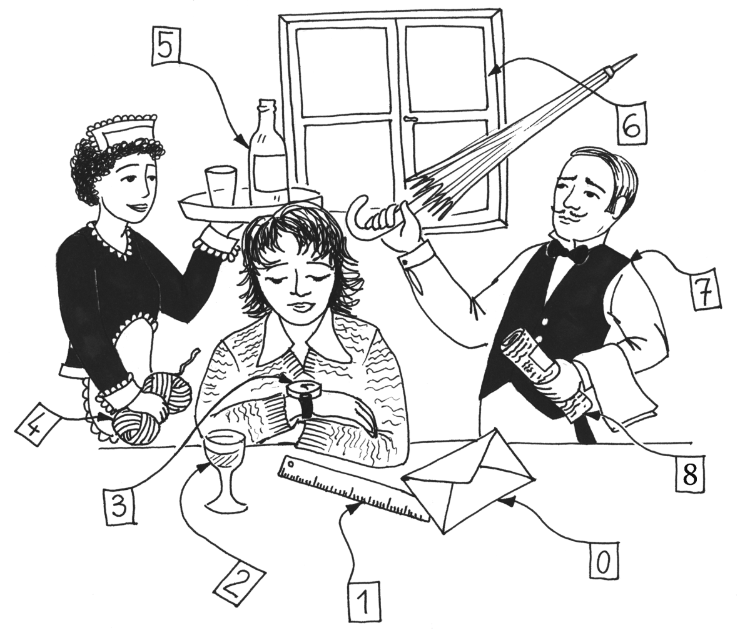

|  |  |  |  |  |  |  |  |  |
| --- | --- | --- | --- | --- | --- | --- | --- | --- |
| **0** | **1** | **2** | **3** | **4** | **5** | **6** | **7** | **8** |
| *E* |  |  |  |  |  |  |  |  |

|  |  |
| --- | --- |
|  | 8 |

besedišče

2. naloga

**Preberi pismo in zapolni vrzeli z besedami v oblačkih. Dve besedi sta odveč. Glej primer 0, ki je že rešen.**

A LETTER FROM JENNY



Hi!

I'm Jenny. I'm eleven years old and I live in a (**0**) *small* village near London. In the

photo you can see my family. The (**1**) _______________ next to me is James, my

brother. He's fifteen years old. He's (**2**) _______________ and hardworking. My mum

is a (**3**) _______________ and my father is a bus driver. My mum works

(**4**) _______________ the morning, but my father must sometimes work in the

afternoon.

My brother (**5**) _______________ a lot of hobbies. He plays the drums. I don't play a

musical instrument. But I (**6**) _______________ to go to music school. What about

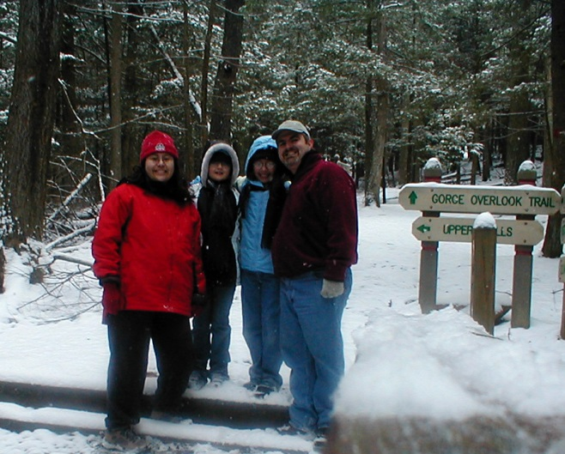you?

Write soon.

Love,

Jenny

|  |  |
| --- | --- |
|  | 6 |

bralno razumevanje

3. naloga

**Preberi besedilo in odgovori na vprašanja. Odgovori kratko – z največ štirimi besedami. Glej primer 0, ki je že rešen.**

FLOATING SCHOOL

There are around 2000 small islands in Sun Bay. Children from some of these islands go to an unusual school. It floats on the sea, so the children get to school by boat. The school floats on empty plastic containers and it goes up and down with the waves. Pupils can watch the sea through the holes in the floor.

School begins at eight. There is no bell, the sound of the drum starts the first lesson.

The children study English, science, history and geography.

Vei is one of the students at this school. Her favourite school subject is geography.

At 11 o’clock the shop boat stops in front of the school. The teachers and the children can buy food there. At 12 o'clock the school is over.

In the afternoon Vei does her homework first and then she goes fishing with her parents. She's a good pupil and her parents are proud of her.

Would you like to visit this unusual school?

**0** How many islands are there in Sun Bay?

*Around 2000.*

**1** How do the children go to school?

**2** When does school start?

**3** Which musical instrument begins the first lesson?

**4** Which school subject does Vei like most?

**5** What comes to the school at eleven o'clock?

**6** Where does Vei go after she finishes her homework?

bralno razumevanje

4. naloga

**Preberi besedilo in ugotovi, ali so povedi v razpredelnici resnične, neresnične, ali v besedilu niso omenjene. Izbrane rešitve označi s kljukico (√). Glej primer 0, ki je že rešen.**

A YOUNG ARTIST

|  |  |
| --- | --- |
| Alex is a 12-year-old boy. He is tall but not very slim. He lives with his parents in a small town.  When he goes for a walk, he always looks for bottles, tins and boxes. Then he makes earrings, lamps and even scissors for his friends. | Opis: scan002 |
|  | Alex hasn’t got a watch. He always asks his mum, “What’s the time?” One day he finds some wire and makes his own clock – a sundial. He makes it in the shape of a chicken.  When it is his mother's birthday, he makes a birthday cake for her. But it isn’t out of flour and eggs. He makes it from a beer can and olive oil tin. He puts some wire round the candle. |
| Alex likes comfortable clothes. He often wears orange trousers and a brown  T-shirt. He uses bright colours while painting. He paints everywhere. He sometimes paints on toilet seats in their farmhouse. He paints toothy big-eyed monsters.  Alex also enjoys inventing things. He makes interesting toys such as miniature  elephant chairs with a reading light. |  |
| He is a child with an artist’s imagination. He has got a lot of fans, but they are all under six. | |

|  |  |  |  |  |
| --- | --- | --- | --- | --- |
|  | | **PRAV** | **NAROBE** | **NI V BESEDILU** |
| 0 | Alex is a short and slim boy. |  | *√* |  |
| **1** | Alex makes things for his friends. |  |  |  |
| **2** | Alex’s clock looks like the sun. |  |  |  |
| **3** | Alex uses four eggs to make a cake. |  |  |  |
| **4** | Alex’s favourite colour is yellow. |  |  |  |
| **5** | Alex paints monsters on toilet seats. |  |  |  |
| **6** | Alex makes toy chairs with a light. |  |  |  |

|  |  |
| --- | --- |
|  | 6 |