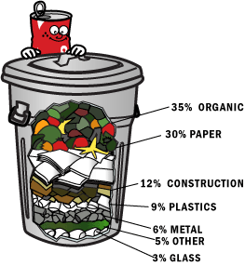**Save the Earth!**

**Think of the future!**

*The population of the world is growing very fast. In the last 40 years, it has doubled. By the year 2020, it will be about 10 billion. Our cities will be much bigger. There will be more factories and more roads. We will need more water and more natural resources. Experts say that we will have serious problems in the future. They say that we must change the way we use energy and natural resources NOW.*

*Recycle it!*

Every day we throw away millions of tonnes of rubbish. Half of this is paper that we can use again. A typical family in Europe and America throws away more than one tonne of rubbish each year, but we can recycle most of this. If we recycle things, we can save money, energy and natural resources. Recycling the Sunday *New York Times* newspaper, for example, will save 75,000 trees every week.

*Reduce it!*

A lot of rubbish that we throw away is not biodegradable. Plastic, metals and chemicals will not disappear for hundreds of years. We also produce a lot of unnecessary things, such as packaging. All of this pollutes the air, the land and the water. Pollution will be a very big problem in the future. We must avoid using non-biodegradable material. We must also reduce the amount of unnecessary things that we produce and use. In shops, for example, we can say "No, thanks!" to plastic bags.

*Save it!*

Many natural resources are not renewable. Coal, gas, oil, metals and minerals, for example, will finish one day. Other resources take a long time to grow, such as trees, or they are not always available, such as water. We have to reduce the amount of resources and energy that we use. We also have to find alternative ways to make energy. We can use the sun, the wind, the sea and the heat of the Earth.

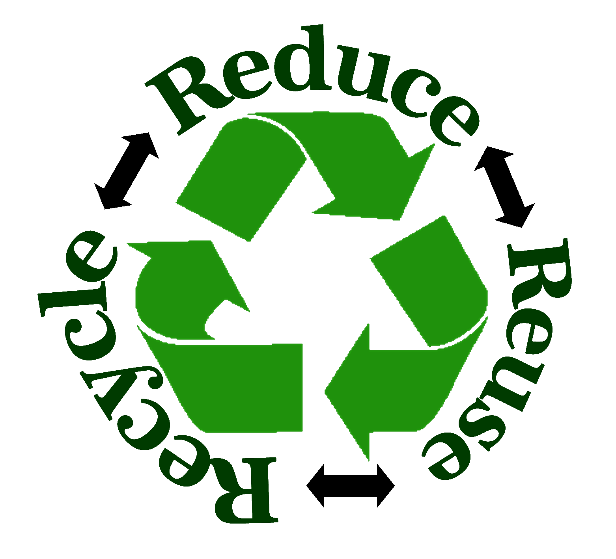

VERBS

to recycle – reciklirati

to reduce – zmanjšati

to reuse – ponovno uporabiti

to save – shraniti, prihraniti, rešiti

to double – podvojiti

to throw away – odvreči

to avoid – izogniti se

NOUNS

population – prebivalstvo

natural resources – naravni viri

advantages – prednosti

disadvantages – slabosti

consequences – posledice

rubbish/litter/trash/waste/garbage – smeti

a landfill - smetišče

plastics – plastika

metal – kovina

glass – steklo

organic waste – biološki odpadki

packaging – embalaža

chemicals – kemikalije

ADJECTIVES

comfortable – udoben

environmental – okoljevarstven, okoljski

available – dosegljiv

renewable – obnovljiv

biodegradable – (bio)razgradljiv

non-biodegradable – nerazgradljiv

necessary – potreben, nujen

unnecessary – nepotreben

alternative – alternativen