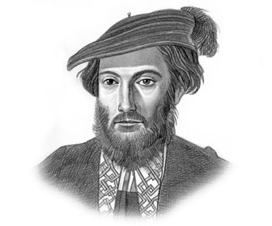 **AMERIGO VESPUCCI**

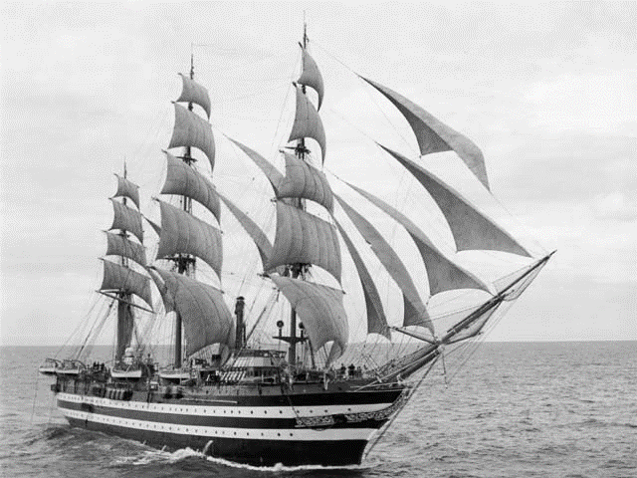Amerigo Vespucci was an Italian [explorer](https://en.wikipedia.org/wiki/Explorer), [financier](https://en.wikipedia.org/wiki/Financier), [navigator](https://en.wikipedia.org/wiki/Navigator) and [cartographer](https://en.wikipedia.org/wiki/Cartographer). He was born in [Florence](https://en.wikipedia.org/wiki/Republic_of_Florence), in the year 1454. In his life, he embarked on four journeys. Vespucci explored South America in the 15th century, after Columbus’s famous journey there. He married Maria Cerezo.

The continent of America got its name after Vespucci.

He died in the year 1512, in Spain.

**Vespucci’s ship**

**INTERESTING FACTS :**

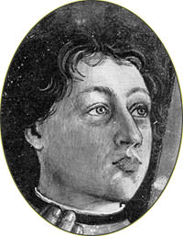- vespucci met with Columbus in 1496

- He made at least two voyages to the New World between 1497 and 1504

- It is believed that he was the first to discover the mouth of the Amazon River

- Amerigo Vespucci was the first to recognize Americas as distinct continents

- The new continent America was named after Amerigo Vespucci

**Portrait of**

**Amerigo Vespucci**

**as a child**