Who really discovered America?

1. If anybody asked you that question you answer would probably be Christopher Columbus. That is what they teach you at school right?

What if everything you knew about discovering Amerika was wrong?

Well I will tell you it is.

1. The first Europeans that stood on American land were actually Vikings.

Leif Eriksson in 1000. That’s nearly 500 years before Columbus.

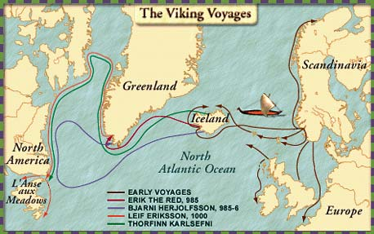

Vikings travel

They went past Iceland and Greenland and landed on the east coast of north America. In 1961, researchers found a Viking village on the east coast of Canada.

WHO WERE VIKINGS?

The Vikings were fierce warriors from Scandinavia, an area in Europe.

They were most powerful in the years 790-1100 CE.

The Viking were champion ship builders and their longboats voyaged all around the coasts Europe and even the Americas. Some of the voyages were violent rides, where gangs of warriors would attack towns and villages along the coast or by rivers. They would kill anyone who fought them. The name ‘Viking means ‘a pirate raid’ in the Old Norse language.

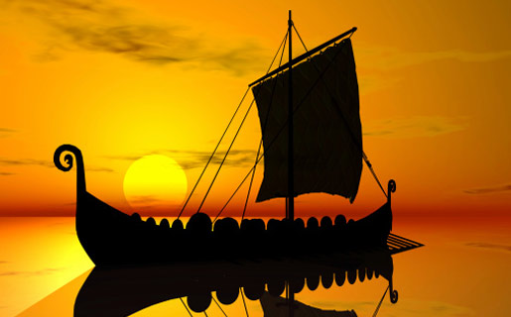

Viking ship



the remains of the Vikings

In 986, Bjarni Herjolfsson, experimented navigator and adventurer, left Norway to reach Iceland close to the winter. He found that his father had left as part of a fleet led by Erik the Red to colonize a huge land situated to the West and attractively named "Greenland.

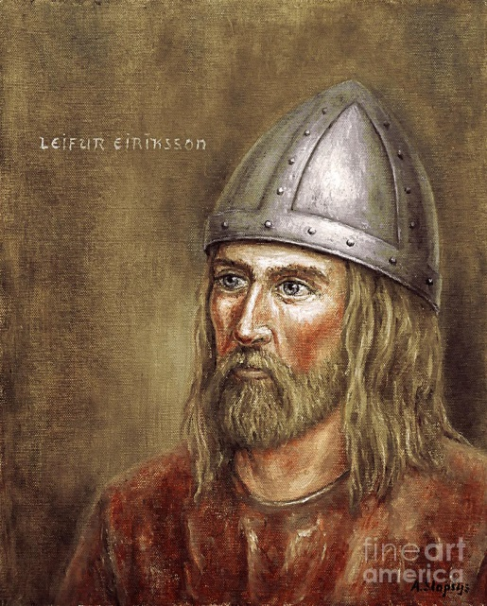

Bjarni Herjolfsson

Video link: <https://youtu.be/61MBhvISXvw>

VOCABULARY:

Discovering- odkrivanje

Researchers- raziskovalci

fierce warriors-grozni bojevniki

an area-območje

fleet- flota

attractively- privlačno

situated- nahaja

Links: <http://www.dkfindout.com/uk/history/vikings/>

<http://easyscienceforkids.com/all-about-leif-eriksson-viking-explorer/>

<http://www.ngkids.co.uk/history/10-facts-about-the-vikings>