Benka Pulko

Who is she?

Benka Pulko spent five years travelling round the world alone on a motor bike. She was born on the 15th of May 1967 in Ptuj. Her occupation is photography and journalism. She wrote many books.

What did she say about her journey?

She said: “One morning when I was waking up I looked into the sealing and quickly decided that I want to travel round the world. With a motorcycle! I have to admit that I did not have a motorcycle back then. I never travelled with it. I did not even know how to ride it. However, that were trivialities, which were fixable.

Five months later, I left for two years, but I came back five and a half years later. I visited 75 countries, from all of the continents and made many friends. And at the end, I even got into the Guinness book of world records.

So that’s me. I love living and enjoying life. That’s probably why I wake up happy every day.”

Interesting facts:

She became the first motorcyclist to reach Antarctica, and the first woman to ride alone across Saudi Arabia. In 2003 she was chosen as Slovenian Women of the year. She holds the Guinness World Record for the longest solo motorcycle ride by a woman in both distance (180,015 km) and duration (2,000 days).

Vocabulary:

Motorbike / motorcycle – motor

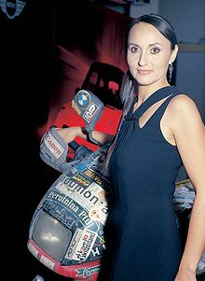Occupation – poklic

Photography – fotografijstvo

Journalism – novinarstvo

Motorcyclist – motorist

Distance - razdalja

To admit – priznati

Trivialities – malenkosti

Probably – verjetno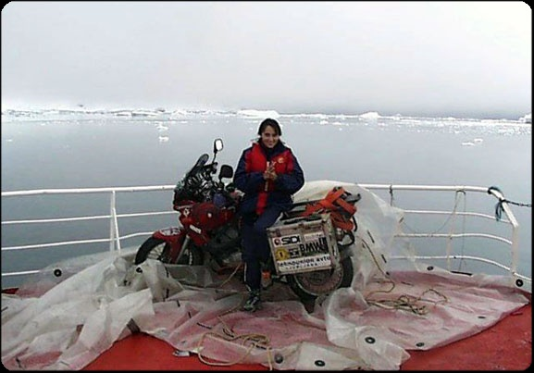 Benka Pulko

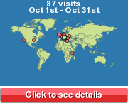

Benka Pulko on her journey the journey of Benka Pulko

Eva Oštir in

Veronika Piber 8. b